Fire Detection using Inception-V3 Transfer Learning CNNs

**Abstract**

Image fire detection has emerged as a vital technology for early fire detection, significantly reducing fire-related losses by promptly alerting users. This method relies on algorithmic analysis of images. However, common detection algorithms, involving both manual and automated extraction of image features, suffer from drawbacks such as lower accuracy, delayed detection, and extensive computational requirements. To address these issues, this paper introduces innovative image fire detection algorithms based on advanced object detection Convolutional Neural Network (CNN) models, including Faster-RCNN, R-FCN, SSD, YOLO v3, and Inception V3. This article presents a deep learning model specifically crafted for recognizing fire and smoke in images. The research entails customizing the widely utilized Inception-V3 Convolutional Neural Network, a common choice for tasks like image classification and object recognition. The modified Inception-V3 is employed on a dataset containing fire images, including those with smoke, for the purpose of detection. An additional optimization function is introduced to improve computational efficiency. The results, inclusive of comparisons with alternative deep learning models and early fire detection approaches, reveal that the Inception-V3-based model excelled, demonstrating superior performance with fewer false positives compared to earlier investigations.

***Index Terms:*** Image Segmentation, Deep Learning, Convolutional Neural Network, Inception V3, Early Fire Detection.

1. **INTRODUCTION**

The swift economic progress has brought about significant challenges in fire control due to the escalating scale and intricacy of constructions. Consequently, there is a pressing need for early fire detection and alarms characterized by heightened sensitivity and accuracy to mitigate fire losses. Conventional fire detection methods, such as smoke and heat detectors, prove inadequate for vast spaces, intricate structures, or environments with numerous disturbances. The shortcomings of these established detection technologies often lead to issues such as missed detections, false alarms, and delays, complicating the achievement of timely fire warnings.

In recent times, there has been a surge in research interest surrounding image fire detection. This method boasts numerous benefits, including early detection of fires, superior accuracy, adaptable system installation, and the ability to efficiently identify fires in expansive spaces and intricate building structures [1].   
The technology operates by utilizing algorithms to analyze image data captured by a camera, discerning the presence of a fire or potential fire risk in the images. As a result, the effectiveness of the image fire detector is directly reliant on the performance of the detection algorithm, making it the central component of this technology.

The image fire detection algorithms comprise three primary stages: image preprocessing, feature extraction, and fire detection. Among these, feature extraction stands out as the crucial element in these algorithms. Traditional algorithms rely on manually selected fire features and machine learning classification. The drawback of such algorithms lies in the necessity for professional knowledge in manually choosing fire features. Despite researchers conducting numerous studies on image features related to smoke and flames, the findings are limited to simple image features like color, edges, and basic textures. This limitation arises due to the complexity of fire types and scenes, presenting a challenge for comprehensive feature discovery. Yet, in practical applications, the complexity of fire types and scenes, coupled with numerous interference events, poses a challenge for algorithms that extract low and middle complex image features. These challenges make it difficult to differentiate between actual fires and fire-like phenomena, resulting in decreased accuracy and weakened generalization ability. Convolutional Neural Networks (CNNs) serve as a foundation for image recognition algorithms, enabling the automatic learning and efficient extraction of complex image features. These algorithms have garnered significant attention and demonstrated outstanding performance in various domains such as visual search, autonomous driving, and medical diagnosis. Consequently, scholars have incorporated CNNs into the realm of image fire detection, innovating self-learning algorithms for the extraction of fire image features [1-9]. Altered the cutting-edge models including AlexNet, VGG, Inception, ResNet, and others, and formulated algorithms specifically designed for the detection of smoke and flames [7,9].

Recent progress in training multilayer neural networks has significantly impacted a diverse range of machine learning challenges, encompassing tasks such as classification and regression. Systems employing multiple layers, commonly termed "deep" architecture, possess the capability to extract more abstract and invariant features from data. This characteristic is believed to endow them with the potential to achieve higher classification accuracy compared to traditional classifiers [10]. The utilization of deep learning models for classification, specifically incorporating spectral and spatial information, has been explored in [11][12]. Additionally, Convolutional Neural Network (CNN) applications in various image processing tasks, particularly for pixel-level labeling issues, have been well-documented. The CNN model facilitates the learning of robust feature representations, enabling the seamless execution of end-to-end labeling tasks. This study involves the development of a cost-effective modified Convolutional Neural Network (CNN) model for the detection of fires in images. Drawing inspiration from the architecture of AlexNet [13], the modified Inception V3 model is tailored for the specific task of fire detection. The investigation aims to overcome certain limitations present in conventional deep learning models designed for fire and smoke detection. Notably, the Inception V3 model's architecture is modified concerning loss functions, symmetric and asymmetric building blocks, and incorporates various elements like convolutions, average pooling, max pooling, concatenations, dropouts, and fully connected layers.

The adapted Inception V3 model is then applied to detect fire and smoke in images. The resulting model demonstrates efficient real-time detection of fire. The significance of this model lies in its potential to contribute to society by enabling the early detection of fires and smoke, thereby aiding in the prevention of potential disasters.

1. **PROPOSED METHOD**
   1. *Convolutional Neural Network Architectures*

CNN, a deep neural feed-forward network, operates on the principles of weight sharing, spatial feature extraction, and reduced computational costs [14]. Originally introduced by LeCun in 1989 for processing visual imagery [15], recent advancements in CNN architectures have shown remarkable performance in object detection, particularly in detecting face masks. CNN-based models adopt the structure of artificial neural networks (ANNs) and act as classifiers, extracting hierarchical features from image data. The network employs activation functions and training algorithms to progressively learn spatial hierarchies of image features [16], with input images given as labels for automatic training.

In CNN, the architecture extends beyond simple input and output layers, featuring additional types of layers such as convolutional layers, pooling layers, and fully connected layers [17]. The convolutional layer, a crucial module, convolves the input image with learnable filters, extracting features. Each filter consists of neurons detecting features for layer inputs, and convolutional learning occurs by sliding the filter over the input image, resulting in feature maps. The number of filters determines the number of feature maps. To reduce dimensionality while preserving essential information, subsampling techniques like average pooling and max pooling are employed [18]. The pooling layer is inserted between two convolutional layers to control overfitting by minimizing redundant representations from the preceding layers. Pooling operations, such as max pooling and average pooling, reduce the number of neurons in the previous convolutional layer. Max pooling is suitable for sparse pooled features, while average pooling enables the network to operate on various frequencies at each layer, enhancing invariance and reducing redundancies [19]. The fully connected layer is responsible for mapping the extracted features from pooling and convolutional layers to the final output, such as object detection [14]. Subsampling, involving various types like average, sum, and maximum, continues until the network is fully connected. In adherence to the principles of object detection algorithms, the workflow of image fire detection algorithms based on convolutional neural networks is illustrated in Figure 1. The detection CNN encompasses functions such as region proposals, feature extraction, and classification. Initially, the CNN processes an image as input and produces region proposals through convolution and pooling operations. Subsequently, the region-based object detection CNN employs convolutional layers, pooling layers, and fully connected layers to determine the presence or absence of fire in the proposed regions.

The convolutional layer stands as a pivotal element within CNNs. Diverging from other neural networks that utilize connection weights and weighted sums, the convolutional layer employs image transforms filters known as convolution kernels to generate feature maps from original images. This layer consists of a set of convolution kernels sliding across images, computing new pixels through a weighted sum of the pixels they traverse to create a feature map. The feature map serves as a representation of specific aspects within the original image. Equation (1) outlines the calculation formula for the convolutional layer.

(1)

**Table 1** Full name of convolutional neural network

Name Full name of convolutional neural network

AlexNet AlexNet  
VGG Very Deep Convolutional Networks for Large-Scale Image Recognition  
Inception Inception  
ResNet Residual Network  
Inception Resnet V2 Inception Residual Version 2  
Darknet-53 Darknet-53  
Faster-RCNN Faster Regions with CNN features  
R-FCN Faster Regions with CNN features  
SSD Single Show MultiBox Detector  
YOLO v3 You Only Look Once Version 3

**No Fire**

**Fire**

**Fully-connected layer**

**Pooling Layer**

**Convolutional Layer**

**Pooling Layer**

**Convolutional Layer**

**Fig. 1**: Flow chart of image fire detection algorithms based on detection CNNs.

In this equation, x represents an input image with dimensions W x H, w corresponds to a convolution kernel with dimensions J x I, b stands for bias, and y represents the output feature maps. The actual values of w and b are determined through the process of training.

* 1. Pre-processing

During this phase, we have the capability to mitigate unwanted distortions and accentuate specific features essential to the given application. These features can vary based on the application's requirements. Image pre-processing encompasses tasks like standardizing images to a uniform resolution and augmenting images to enhance the model's ability to generalize its learning. Resizing images holds particular significance in computer vision, and for the proposed model's training, every image has been resized to 224x224 pixels. Data augmentation [20] involves artificially creating variations in images to enhance the model's generalization. One technique, horizontal flip augmentation, involves reversing entire rows and columns of images horizontally. One hot encoding which used to represent categorical variables as binary vector. In this context, this acts as encode class labels (0,1). A Convolutional Neural Network (CNN) has the capability to process input images within its intricate neural network architecture. It assigns learnable weights and biases to different elements, facilitating the extraction of features from raw images. The network then makes decisions based on the organized feature set [21][22]. In this architecture, a Max Pooling 2D layer is incorporated with a pool size of 3x3. A Conv2D layer utilizes ReLU for activation and strides of 4x4, operating on an input size of 224x224x3. For the dense layer, the softmax activation function is employed.

If we have an input image representing as X and a filter representing with f, then the expression would be:

The * indicates the convolutional operator and x is the input vector. The linear transformation of weight vectors and input vectors as

Here, X is the input, W is the weight, and b (bias) is a constant.

* 1. Inception V3 model for fire detection

**Fig.2:** High-Level Diagram of Inception V3 Model [23]

As depicted in Figure 1, the structure of the Inception V3 Model is organized into distinct inception blocks. Each inception block may include various combinations of layers, such as Convolution layer, AvgPool layer, MaxPool layer, Concat layer, Dropout layer, Fully Connected layer, and Softmax output. The diagram illustrates that during the learning process, the Inception V3 Model can generate multiple softmax outputs. This model incorporates Factorizing Convolutions, which accelerates the training process by reducing the number of connections. Moreover, it acts as a preventive measure against overfitting by minimizing the parameters that need to be learned [23].

Google designed the Inception models primarily for image classification within CNN frameworks, setting them apart from conventional CNNs due to differences in architecture and the arrangement of inception blocks. In the instance of Inception V3, it processes the same input tensor, utilizes multiple filters, and concatenates their outcomes efficiently, as depicted in Figure 2. The integration of a dropout mechanism introduces a probabilistic approach, randomly excluding certain layers from the entire architecture during training, effectively lowering computational costs. In this study, a dropout ratio of 0.5 is considered.

In the realm of machine learning and statistics, the learning rate plays a crucial role in tuning the speed of the model. For the proposed models, a learning rate of 0.001 is employed after fine-tuning. Simplistically, optimizers, along with the loss function, shape the model by adjusting weights to produce the most accurate form. This investigation utilizes the Adam optimizer and RMSProp as moment. Optimization involves calculating the exponentially weighted average of past gradients (vdW) and the exponentially weighted average of the squares of past gradients (sdW). Bias correction is computed using Eq. (5) and Eq. (6), tending towards zero. Parameter tuning optimizes the model by updating parameters in each iteration, minimizing the loss function temporarily. Ultimately, parameters are updated using information from the calculated averages. The Adam optimizer can be computed using Eq. (3) and Eq. (4).

Where is the exponentially represents the exponentially weighted average of past gradients, while stands for the exponentially weighted average of past squares of gradients. is hyperparameter to be tuned. is hyperparameter to be tuned. is cost gradient with respect to current layer. Eq (5) (6) depict the modified optimization, derived from the calculations in Eq (3) (4). The ultimate adjustment to the weight matrix of the network is executed using Equations (5) and (6) as presented below:

(7)

W is the weight matrix (parameter to be updated) and is the learning rate, is very small value to avoid dividing by zero.

* 1. RMSProp

RMSProp is employed as the loss function in this study. The computation of RMSProp involves the exponentially weighted average of squares, aimed at achieving fast convergence, as expressed below:

Eq. (8) shows RMSProp where s is the exponentially weighted average of past squares of gradients. ∂J/∂W refer the gradient in terms of current layer weight vector. W denotes the weight vector. β is hyperparameter to be tuned, and α denotes the learning rate. ϵ is taken as very small to avoid dividing by zero.

Equation (10) presents the Loss function equation, where y represents the scalar value in the model output, computed according to Equation (11). Here, x corresponds to the corresponding target value, and the output size indicates the number of scalar values in the model output.

1. **EXPERIMENTAL RESULT**

This section presents the experimental outcomes of the proposed Inception V3 model for the fire detection task, including a comparative analysis. The dataset details are also outlined in this section. The implemented deep learning model, alongside baseline models, was executed using Python 3.8 with standard python libraries, such as Keras, Tensorflow were employed for this study.

* 1. a, Collection of Dataset

To effectively train and validate the neural network, a substantial number of images is necessary. The dataset utilized in this study was sourced from Kaggle and is categorized into two sets: Training and Testing. The training dataset is employed to teach the neural network to discern images containing fire from those without fire. Each set further comprises two classes: Fire and Non_fire. The training dataset encompasses 1167 images in the Fire calss and 275 images in the Non_fire class, resulting in a total 1,442 images. Meanwhile, the testing part consisting of 998 images in total. Additionally, the proposed model was tested on real-time datasets created for this experiment.

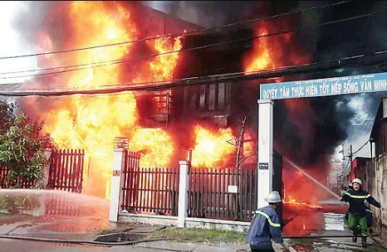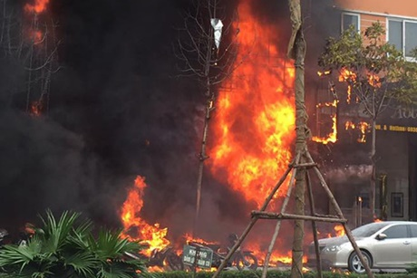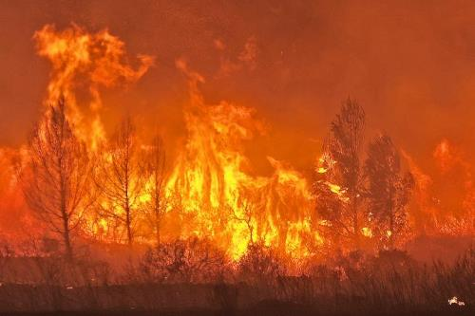

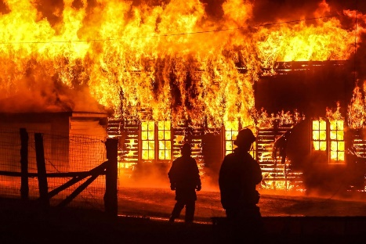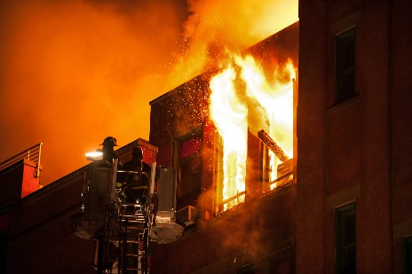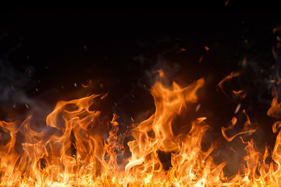

***Fig.3:*** Samples images of Fire dataset

* 1. Result and Discussion

After training, both the proposed model and existing deep learning-based models underwent testing on real datasets. The model obtains high accuracy and low validation loss score. To assess the performance of the transfer learning model, various performance metrics were employed, including Accuracy, Precision, Sensitivity, Specificity, Intersection over Union (IoU). The Classification error is formulated in terms of where represents the one-hot encoded vector, and represents the predicted probability.

Accuracy = (1)

(2)

(3)

Specificity = (4)

IoU = (5)

***Fig.4,5:*** Comparision of performance of model during training and Confusion Matrix

Additional performance metrics are expressed in terms of True Positive (TP), False Positive (FP), True Negative (TN), and False Negative (FN). These metrics are organized into a grid-like structure known as the confusion matrix. In this study, two confusion matrices are created to assess the model's performance during both training and testing phases. The two confusion matrices are visually presented in Fig. 5. Furthermore, Fig. 4 illustrates a comparison of the area under precision, loss, and accuracy curves during the training and testing of the model. The transfer learning model Inception V3 neural network demonstrates high accuracy in detecting fires in both indoor and outdoor environments, the evaluation of the proposed system incorporates standard metrics such as precision, recall, and F1 score. Additionally, the comparision includes an assessment of dataset size, considering whether previous methods focus on fire, smoke, or both. The system is also benchmarked against two state-of-art fire detection systems, specifically the fire detection system based on deep learning.

1. Conclusion

From this study, the leading proposed deep learning model is constructed through the transfer learning of Inception V3. Image augmentation techniques are applied to enhance the model’s performance by increasing the diversity of the training data. The model achieved 100% accuracy in both training and validation during testing on the train dataset. Moreover, by leveraging large volumes of data, the model can be extended to classify different types of fires in both indoor and outdoor environments. The ensemble approach not only contributes to high accuracy but also significantly improves detection speed. Additionally, transfer learning on pretrained models, combined with rigorous testing on an unbiased dataset, results in a reliable and cost-effective solution. In the future, combined with several methods to surveillance and analysis the devastating caused by fire in the early stages.

**References**

**[1]** K. Muhammad, J. Ahmad, I. Mehmood, et al., Convolutional neural networks based fire detection in surveillance videos, IEEE Access 6 (2018) 18174–18183.  
**[2]** C. Tao, J. Zhang, P. Wang, Smoke detection based on deep convolutional neural networks, in: 2016 International Conference on Industrial Informatics - Computing Technology, Intelligent Technology, Industrial Information Integration (ICIICII), 2016, pp. 150–153.   
**[3]** A. Filonenko, L. Kurnianggoro, K. Jo, Comparative study of modern convolutional neural networks for smoke detection on image data, in: 2017 10th International Conference on Human System Interactions (HSI), 2017, pp. 64–68.   
**[4]** Z. Yin, B. Wan, F. Yuan, et al., A deep normalization and convolutional neural network for image smoke detection, IEEE ACCESS 5 (2017) 18429–18438.  
**[5]** A.J. Dunnings, T.P. Breckon, Experimentally defined convolutional neural network architecture variants for non-temporal real-time fire detection, in: 2018 25th IEEE International Conference on Image Processing (ICIP), 2018, pp. 1558–1562.   
**[6]** A. Namozov, Y. Cho, An efficient deep learning algorithm for fire and smoke detection with limited data, Adv. Electr. Comput. Eng. 18 (2018) 121–128.   
**[7]** W. Mao, W. Wang, Z. Dou, Y. Li, Fire recognition based on multi-channel convolutional neural network, Fire Technol. 54 (2018) 531–554.   
**[8]** K. Muhammad, J. Ahmad, S.W. Baik, Early fire detection using convolutional neural networks during surveillance for effective disaster management, Neurocomputing 288 (2018) 30–42.   
**[9]** Y. Hu, X. Lu, Real-time video fire smoke detection by utilizing spatial-temporal ConvNet features, Multimed. Tool. Appl. 77 (2018) 29283–29301.  
**[10]** N. Kruger, P. Janssen, S. Kalkan, M. Lappe, A. Leonardis, J. Piater, A. J. Rodriguez-Sanchez, and L. Wiskott, “Deep hierarchies in the primate visual cortex: What can we learn for computer vision?,” IEEE Transactions on Pattern Analysis and Machine Intelligence, vol. 35, no. 8, pp. 1847–1871, Aug 2013.   
**[11]** Y. Chen, X. Zhao, and X. Jia, “Spectral-spatial classification of hyperspectral data based on deep belief network,” IEEE Journal of Selected Topics in Applied Earth Observations and Remote Sensing, vol. 8, no. 6, pp. 2381–2392, 2015.   
**[12]** J. Li, J. M. Bioucas-Dias, and A. Plaza, “Spectral-spatial classification of hyperspectral data using loopy belief propagation and active learning,” IEEE Transactions on Geoscience and Remote Sensing, vol. 51, no. 2, pp. 844– 856, 2013.  
**[13]** Krizhevsky A, Sutskever I, Hinton GE (2012). “ImageNet Classification with Deep Convolutional Neural Networks”. Advances in Neural Information Processing Systems. vol. 25.  
**[14]** M. Jiang, X. Fan, Retinamask: a face mask detector. ArXiv 2020.  
**[15]** S.V. Militante, N.V. Dionisio, Deep learning implementation of facemask and physical distancing detection with alarm systems, Proceeding - 2020 3rd Int. Conf. Vocat. Educ. Electr. Eng. Strength. Framew. Soc. 5.0 through Innov. Educ. Electr. Eng. Informatics Eng. ICVEE 2020, 2020  
**[16]** R. Yamashita, M. Nishio, RKG. Do, K. Togashi, Convolutional neural networks: an overview and application in radiology, Insights Imaging (2018)  
**[17]** AR. Pathak, M. Pandey, S. Rautaray, Application of deep learning for object detection, in: Procedia Comput. Sci., vol. 132, Elsevier B.V., 2018, pp. 1706–1717  
**[18]** M. Mahdianpari, B. Salehi, M. Rezaee, F. Mohammadimanesh, Y. Zhang, Very deep convolutional neural networks for complex land cover mapping using multispectral remote sensing imagery, Remote Sens. (2018)  
**[19]** J. Gu, Z. Wang, J. Kuen, L. Ma, A. Shahroudy, B. Shuai, et al., Recent advances in convolutional neural networks, Pattern Recognit. (2018)

**[20]** Sun D, Roth S, Black MJ (2010). “Secrets of optical flow estimation and their principles”. in: Proceedings of the 2010 IEEE Conference on Computer Vision and Pattern Recognition (CVPR), IEEE, pp.2432–2439  
**[21]** Li P, Zhao W (2020). “Image fire detection algorithms based on convolutional neural networks”. 2020 Elsevir Fire Safety Journal - Case Studies in Thermal Engineering 19, 100625  
**[22]** Krizhevsky A, Sutskever I, Hinton GE (2012). “ImageNet Classification with Deep Convolutional Neural Networks”. Advances in Neural Information Processing Systems. vol. 25.  
**[23]** Patel, Khush. (2020) “Architecture comparison of AlexNet, VGGNet, ResNet, Inception, DenseNet”